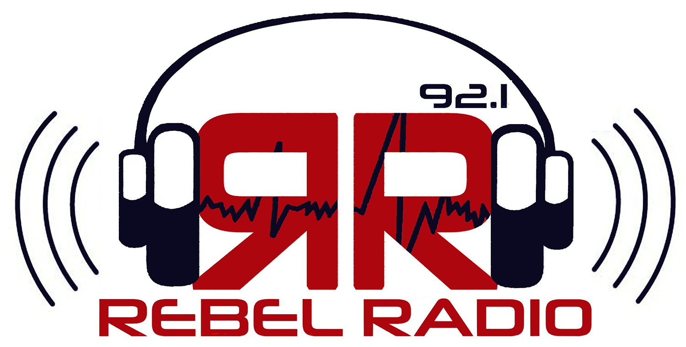

MULTI-PLATFORM ADVERTISING BUNDLES
Package #1: Quarter-page print ad in the DM
20 commercials on Rebel Radio WUMS-FM92.1
300x250 rectangle banner ad on thedmonline.com
$300 ($350 if bought separately)

Package #2: Half page print ad in the DM
35 commercials on Rebel Radio WUMS-FM92.1
300x250 rectangle and 728x90 leaderboard ad on dmonline.com
$500 ($700 if bought separately)

We can also customize any multi-platform ad package for you. Call 662 915-5503 for more information

