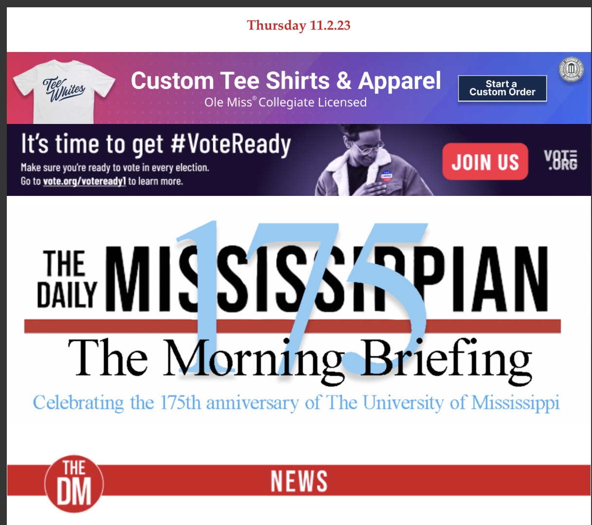

**GET YOUR BUSINESS IN FRONT OF OLE MISS STUDENTS & DM READERS FIRST**

In advance of every print publication The Daily Mississippian sends out a weekly morning news briefing to all enrolled students and other e-newsletter subscribers – it’s a number that’s now over 27,000 and still growing! And your business can be part of it.

Get a 728x90 clickable ad (like the ones above or the one below) on the DM Morning Briefing for only $100 a week or get a whole month for only $300 and save. The ad can link to your website and gets your message out to every student on campus plus our most loyal readers with their morning coffee.

**THIS COULD BE YOUR AD!**

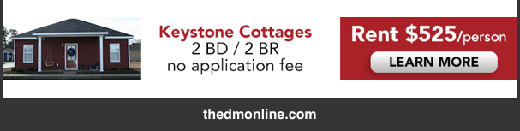

To book your newsletter ad today email [dmads@olemiss.com](mailto:dmads@olemiss.com) or contact your ad representative